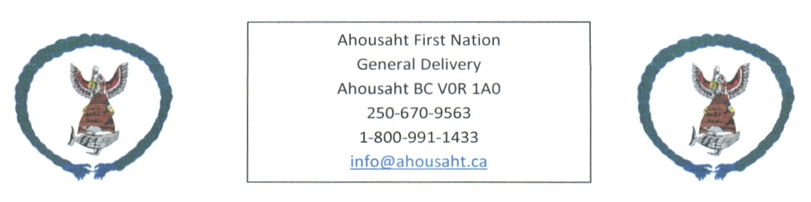

Ahousaht Covid Update ~ October 12, 2021

Covid19 has been in our community since September 4th, 2021

Active Cases - 13
In community | 4
Away from home | 9

Recovered – 72
In Community | 50
Away from home | 24

Cases Total – 87
Households – 4

Vaccinated
 | 1 vaccine | 2 vaccines
18 and over | 513 | 458
12 – 17 years | 57 | Awaiting confirmation information from CHS

Hospitalized Cases – 3

Vancouver Island Region – Active cases - 274
North Van Island | 61 | Campbell River | 16
Vancouver Island West | 2 | Courtney area | 42
Alberni Clayoquot Region | 94 | Nanaimo | 57
Cowichan Valley West | 2 | South Vanc Island | No information

We have members who continue to isolate and/or recover; we also have members awaiting testing/results.

Partying: Continues to be a huge concern from Families, Leadership and Health staff. The partying needs to stop. We need everyone to help bring our family member’s home.

Isolation: will need a support person; we encourage for homes in isolation have a tote outside for people to drop off items. If you are interested, we can provide with a care kit (per home), email eoc@ahousaht.ca

Any questions or recommendations, email eoc@ahousaht.ca

