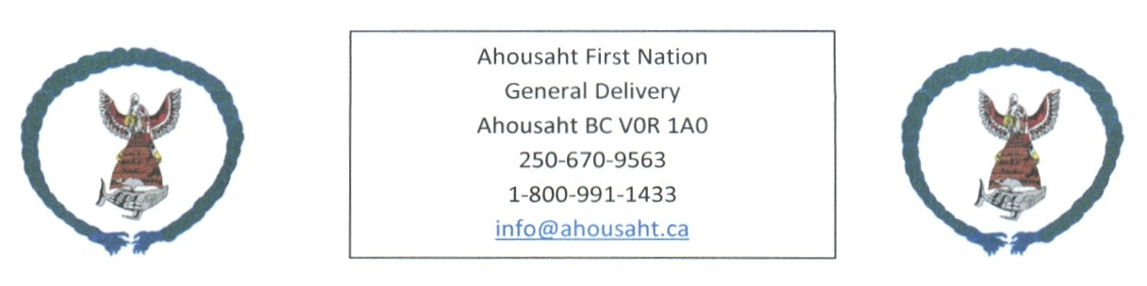

Ahousaht Covid Update
September 24, 2021

Covid19 has been in our community since September 4th, 2021

Active Cases -
In community | 18
Away from home | 4

Cases Total – 60

We have members who continue to isolate and/or recover

Recovered – 23
In Community | 26
Away from home | 12

Vaccinated
 | 1 vaccine | 2 vaccines
18 and over | 508 | 428
12 – 17 years | 57 | Awaiting confirmation information from CHS

Hospitalized Cases – 1

Partying: Great concerns from Family, Leadership and Health staff are the partying. We need everyone to help get our family members home, to bring them home.

Prior to today, the numbers reflected what Leadership was aware of, today updates include details from NTC nursing team. We do not have all names; we are aware of those who have notified Leadership.

Isolation: Support, we encourage for homes in isolation have a tote outside for people to drop off items.
If you are interested, we can provide with a care kit, email eoc@ahousaht.ca

Any questions or recommendations, email eoc@ahousaht.ca

